**Summary of Equipment**

Table __ shows the specification of the equipment used in the coal-fired power plant. Some details of each component are also listed such as the tag number and selection parameter. The page number of the catalogue is also included in the table.

**Table __**

**Summary of Equipment**

|  |  |  |  |  |
| --- | --- | --- | --- | --- |
| **Tag No.** | **Component** | **Selection Parameter** | **Specification** | **Page No.** |
|  | Boiler | **Fuel:** Sub-bituminous Coal  **Capacity:**  **Pressure:** 200 bar  **Temperature:** 540 °C  **Reheat Pressure:**  **Reheat Temperature:** | **Model:**  **Typical Fuels:** Bituminous, Sub-bituminous, Lignite A, Oil and Gas  **Capacity:** up tp 1,350 MWe  **Pressure:** up to 330 bar  **Temperature:** 650 °C / 670 °C  **Reheat Pressure:** 330 bar  **Reheat Temperature:** 670 °C |  |
|  | Steam Turbine | **Power Output:** 500 MW  **Inlet Pressure:** 200 bar  **Inlet Temperature:** 540 °C | **Model:**  **Capacity:** up to 500 MW  **Pressure: up to** 260 bar/ 3770 psi  **Temperature: up to 600** °C/ 1112 °F  **Reheat Temperature: up to 610** °C/ 1130 °F |  |
|  | Condenser | **Pressure:** 55 mbar  **Circulating Water Temperature:** 34.58 °C | **Model:**  **Condenser Thermal Load:** 1,820 MW  **Absolute Pressure:** 55 mbar  **Circulating Water Temperature:** 25 °C |  |
|  | Closed Feedwater Heater | **Low Pressure Rating:** 406-623 psig  **High Pressure Rating:** 1653-1740 psig | **Model:**  **Low Pressure Rating:** 400-800 psig  **High Pressure Rating:** 1600-4800 psig |  |
|  | Deaerator | **Mass flow rate:** | **Tank Volume:** 11,575 liters  **Steam Requirements:** 3240 kg/hr |  |
|  | Boiler Feed Pump | **Pressure:** 58 bar  **Temperatue:** 268 °C  **Efficiency:** 86.23 % | **Flow:** 5220 m3/h  **Head:** 4270 m  **Pressure:** 517 bar (7500 psi)  **Temperature:** 315 °C (600 °F) |  |
|  | Condensate Extraction Pump | **Pressure:** 0.055 bar  **Temperature:** 34.58 °C | **Flow:** 13,600 m3/h (60,000 gpm)  **Head:** 1070 m (3500 ft)  **Pressure:** 100 bar (1450 psi)  **Temperature:** 230 °C (450 °F) |  |
|  | Circulating Water Pump | **Pressure:** up to 5 bar  **Temperature:** 30 °C | **Flow:** 181 700 m3/h  **Head:** 110 m (350 ft)  **Pressure:** 5 bar (75 psi)  **Temperature:** up to 65 °C |  |
|  | Generator | **Power:**  **Efficiency:** 100 % | **Frequency:** 60 Hz  **Power Factor:** 0.85  **Apparent Power:** up to 1,120 MVA  **Efficiency:** up to 98.9 %  **Terminal Voltage:** up to 26 kV |  |

The table above shows the list of equipment and specifications used in the design of the proposed coal-fired power plant. Each component is named with tag numbers and has selection parameter used in the calculation of the design options.

**Equipment Description**

Each component plays an important role in a power plant to have an efficient performance. The major equipment of the proposed coal-fired power plant are briefly discussed below.

1. Steam Turbine

The steam turbine is a prime mover for the conversion of heat energy of steam into work on a revolving shaft, utilizing fluid acceleration principles in jet and vane machinery. The chosen turbine STF – D850 is manufactured by GE which consists of double-flow LP sections and a separate HP. The main inlet pressure is up to 245 bar with main steam inlet and reheat temperatures up to 585 °C. The operating capacity of the steam turbine is up to 1000 MW with steam turbine efficiency of 49%.

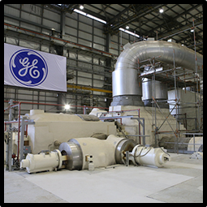

**Figure _.** STF Turbine, GE

2. Boiler

The steam boiler is an integrated assembly of several essential components the function of which is to produce steam at a predetermined pressure and temperature. The chosen boiler design is manufactured by GE with up 1350 MW electrical for coal units. The type of fuel used is sub-bituminous coal which is suitable for the design of the boiler. Its operating pressure ranges up to 330 bar with temperature up to 650 °C.

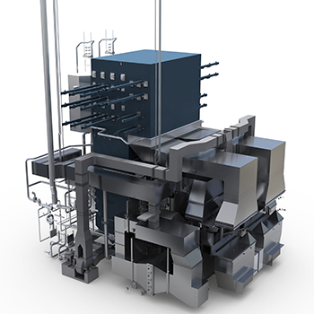

**Figure _.** Two Pass Boiler, GE

3. Condenser

A condenser's primary function is to maintain low pressure on the exhaust side of steam turbine rotor. This helps the steam to spread to a greater degree, resulting in an improvement in the resources available for mechanical work conversation. The secondary function of the condenser is to supply the boiler with pure and hot feed water, as the condensed steam discharged from the condenser and collected in a hot well can be reused as the boiler's feed water. Using a condenser at a power plant is to increase the power plant's output by raising the steam exhaust pressure below atmospheric pressure. The proposed power plant used GE Single Vacuum Type Condenser having a pressure of 55 mbar and a thermal load of 1820 MW.

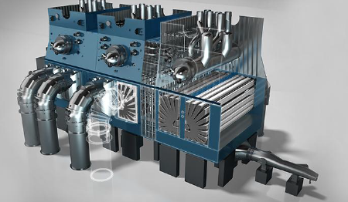

**Figure _.** Condenser, GE

4. Closed Feedwater Heater

For a traditional power plant, a feed-water heater is used to preheat boiler feed water. The heat source is steam bled from the turbines, and the goal is to increase the cycle's thermodynamic efficiency. The most popular feedwater heater design is a shell and tube exchanger with the feedwater flowing within the tubes and the external steam condensation. The proposed power plant used Energyen SPX Heater that can be installed in both low and high pressure.

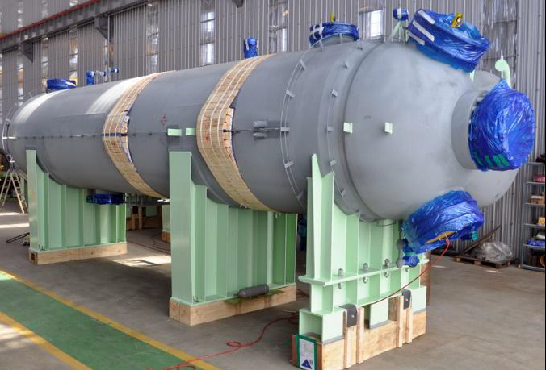

**Figure _.** SPX Heater, Energyen

5. Deaerator

Deaerators are mechanical devices that extract dissolved gasses from feedwater in boilers. Deaeration protects the steam system against the effects of corrosive gases. This is achieved by reducing the dissolved oxygen and carbon dioxide content to a point where corrosion is minimized. Deaerators use steam to heat water to the maximum saturation temperature corresponding to the deaerator's steam pressure, and to scrub and take dissolved gases away. The steam flow may be parallel, opposite, or counter to the flow of water. The deaerator consists of a portion of deaeration, a storage tank and a ventilator. In the deaeration part, it is heated and agitated by steam bubbles through the water. Steam is cooled by water flowing in and condensed at the condenser vent. The vent emits non-condensable gases and some steam.

6. Boiler Feed Water Pump

A BFP or boiler feed pump is used in boiler feed water system to increase the water pressure; high enough so it can be pumped into the boiler drum. It helps maintain proper working of a boiler providing continues feed water supply. A continues feed water supply is essential for steam boilers; as it not only avoid overheating but any further damage to the boiler. Boiler feed pump must not only be able to supply feed water requirement; but also work as a condensate and makeup water pump when required. To ensure proper operation of these pumps; feed water must be free from steam, air and insoluble solids.

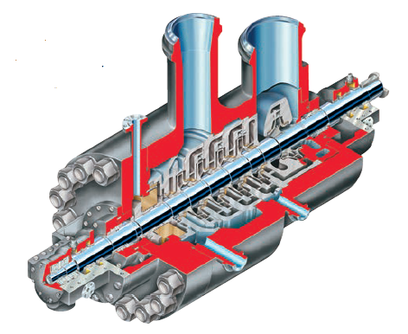

**Figure _.** Boiler Feedwater Pump, FLOWSERVE

7. Condensate Extraction Pump

The CEP or condensate extraction pump is used to do the initial part that draws the condensate under vacuum from the condenser hot well with some positive pressure at the discharge. This water, after passing through several heaters and deaerators, reaches the suction of the BFP that is used to pump water at a very high pressure. It sends the water to the boiler after it passes through a number of HP heaters

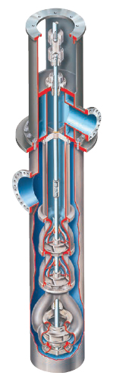

**Figure _.** Condensate Extraction Pump, FLOWSERVE

8. Circulating Water Pump

The purpose of circulating water pump is to provide cooling water for the condenser. The water that will be used is from Nasugbu Bay then pumped through the tubes in condenser to remove the heat of vaporization from steam exiting the turbine. These pumps will circulate the cooling water or circulating water for a higher efficient performance of the proposed power plant.

9. Drip Pump

After the feedwater heater, the extracted steam will be converted into drip which is pumped by the drip pump back to the previous reheater. Drip goes in opposite direction of feedwater. The extracted steam rejects heat in Low Pressure Feedwater Heater 3 then drip will go to Low Pressure Feedwater Heater 2 because the temperature or enthalpy of drip in Heater 3 is more that Heater 2.

10. Generator

The heat is produced from a source in a steam turbine powered generator. sThere is a boiler containing water, and the heat is used to turn it into high temperature, high pressure steam. Steam output depends on the heat transfer flow rate and surface area, and the heat used for combustion. This boiler steam is forced through nozzles into the turbine which spins the blades mounted on a shaft. The steam turbine consists of a casing that is fastened to stationary blades within and a rotor has rotating blades on the periphery. The proposed power plant used Water Cooled GIGATOP Generator with an apparent power of 1,120 MVA and efficiency up to 98.9 %.

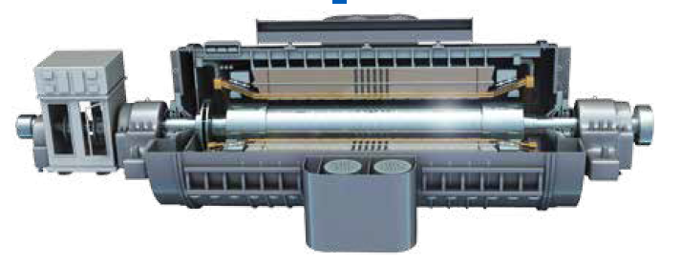

**Figure _.** Water-Cooled Generator, GIGATOP

11. Pulveriser

After the coal has been transported from Caluya, Antique. It will be prepared in the pulveriser for higher combustion efficiency. There will be a hopper that will transfer the coal to the pulveriser until it reached the boiler through the feeder. The pulverized coal will be transported to the feeder for combustion

12. Chimney

The exhaust gases or smoke produced by boiler is exhausted in the chimney. These exhaust gases are referred as flue gas which are discharged to the atmosphere at such a height that the pollutants are kept within acceptable limits at ground level. For coal-fired power plants, flue gas is typically at about 120 °C. For the system, Natural Draught will be used as the proposed power plant will be using a chimney. For units with a capacity of 500 MW, flues are about 200 m high and 6 m in diameter.